Task Management System Answer Guide

1. Project Overview
Task Management System is one of the most important tools when you want to organize your tasks. This project aims to develop a task management system based on Node.js, Express, JavaScript, HTML, Bootstrap, CSS and PostgreSQL. The system allows users to create an account, add friends, and create individual or group projects for work, study, or personal use. Users can assign friends to their projects and create tasks within each project. Tasks can be moved from to-do to in-progress and completed sections using drag and drop in a kanban style. Through the development of this project, students will learn and master fundamental technologies in modern web development, including backend frameworks, database operations, and API design.

2. Features
- User authentication: Users can log in, create an account, and add friends who are also users of the app.
- Task management: Users can create tasks in the project, specify deadlines, priorities, and statuses. The system needs to classify and display tasks based on their status, which includes to-do items, in progress, and completed tasks.
- Middleware: The app uses middleware for HTTP logging and error handling.

3 Development Process

3.1 Environment Setup
Required Software:
- Node.js: JavaScript runtime environment. Download and install from Node.js official site.
- npm: Node package manager, comes with Node.js installation.
- Git: Version control system. Download and install from Git official site.
- Postman: API development tool to test APIs. Download from Postman official site.
- Visual Studio Code (VSCode): Code editor. Download from VS Code official site.
Verify installation by running node -v and npm -v in the terminal.

3.2 Install Git
Download and install Git from the official site. Configure Git by setting your username and email:
git config --global user.name "Your Name"
git config --global user.email "youremail@example.com"

3.3 Initialize Node.js Project
- Install Dependencies
npm install

3.4 Database Design
The app uses PostgreSQL for the database and has the following schema:
CREATE TABLE users (
id SERIAL PRIMARY KEY,
user_name VARCHAR(255) NOT NULL,
first_name VARCHAR(255) NOT NULL,
last_name VARCHAR(255) NOT NULL,
email VARCHAR(255) UNIQUE NOT NULL,
password_hash VARCHAR(255) NOT NULL
);
CREATE TABLE tasks (
id SERIAL PRIMARY KEY,
user_id INT,
CONSTRAINT fk_tasks_users
FOREIGN KEY(user_id)
REFERENCES users(id)
ON DELETE CASCADE,
name VARCHAR(255) NOT NULL,
description TEXT,
creation_date DATE,
due_date DATE,
due_time TIME,
priority_level INT,
status INT
);
Set up PostgreSQL database and run the schema.
  - Execute schema.SQL to create a database table organization,
  - execute seeds.SQL to generate virtual data

3.5 Database Config Setup
Configure database information in models/index.js
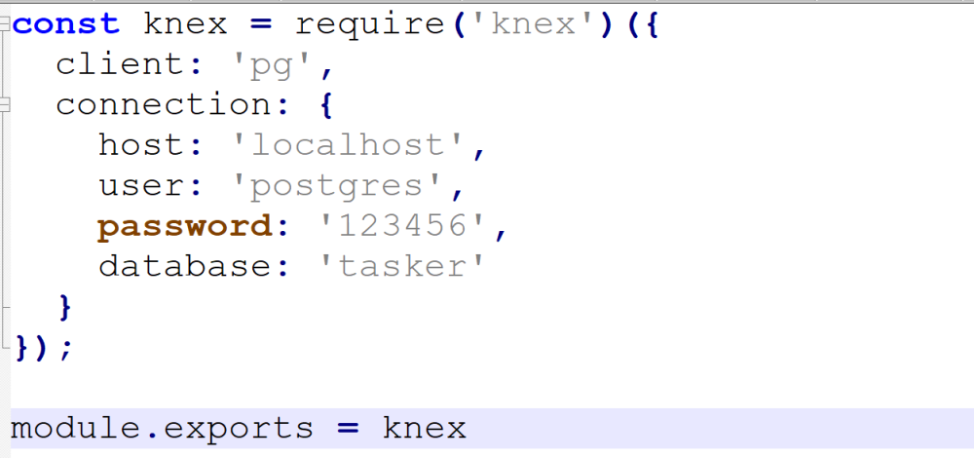

3.6 How to Run the App
- Run npm start to start the server.
node app.js
- Open your browser and go to http://localhost:3000 to access the app.

3.6 Implement User Authentication
You need to define relevant routes in path controllers/users.js and implement database operations based on knex in model/users.js. We have implemented the post /users interface, you can refer to this interface to implement other interfaces
Method | Path | Result
Get | /users/:email | User login： Obtain user information based on email
Post | /users | Register a new user
Put | /users/:id | Update user information based on user id

3.7 Implement Task Authentication
You need to define relevant routes in path controllers/tasks.js and implement database operations based on knex in model/tasks.js. We have implemented the get /tasks/:id interface, you can refer to this interface to implement other interfaces
Method | Path | Result
Get | /tasks/:id | Delete a specified task based on task id
Get | /tasks/users/:id | Get all tasks of the current user
Post | /tasks | Create a new task
Delete | /tasks/:id | Delete a specified task
Put | /tasks/:id | Update a specified task

3.8 Testing and Debugging

3.9 Documentation and Final Submission
Write Project Documentation
- Document the project structure, setup, and usage.
API Documentation
- Document all API endpoints using tools like Postman.
Submit the Project
- Ensure all code is committed to the Git repository.
- Submit the source code, documentation, and any other required files.

5 Screenshots
- Login Page:
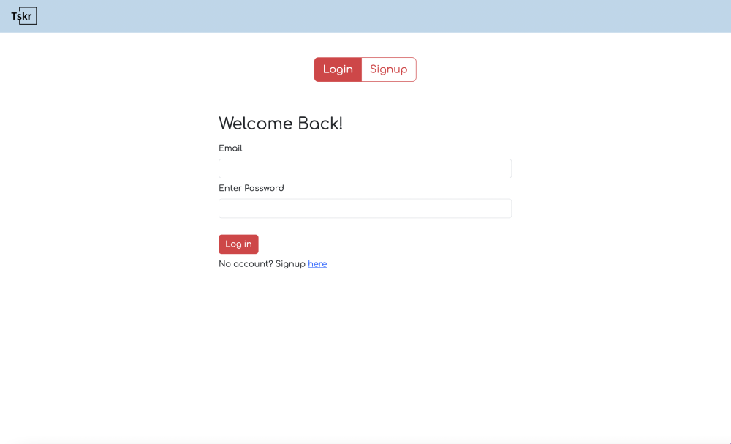
- SignUp Page
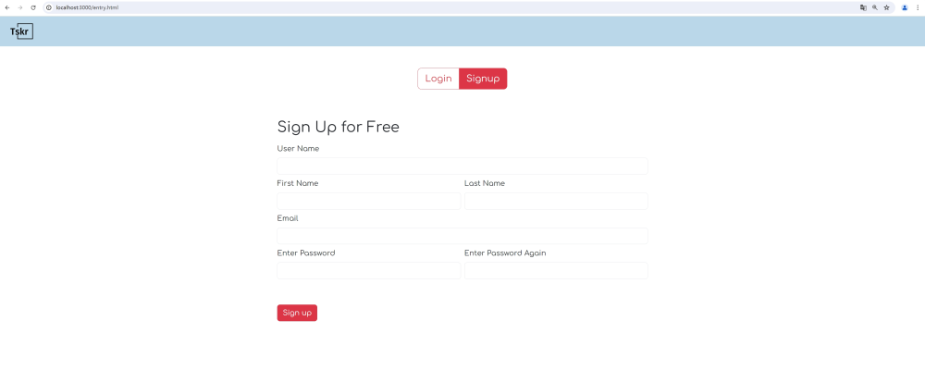
- index page
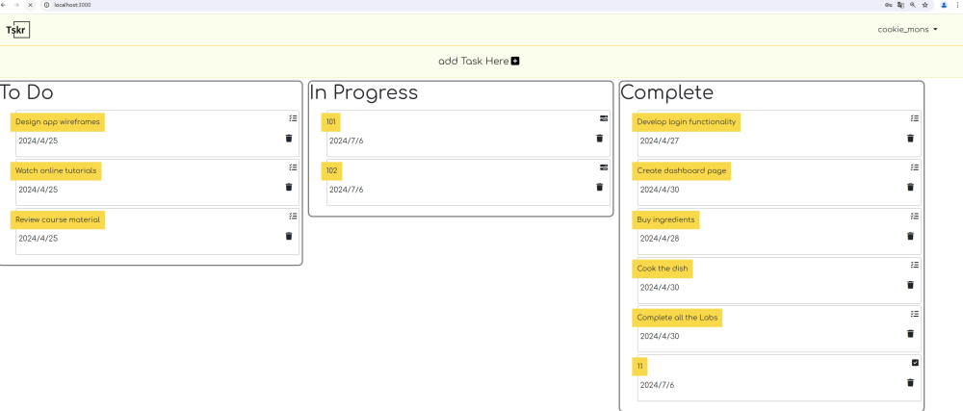
- add task page
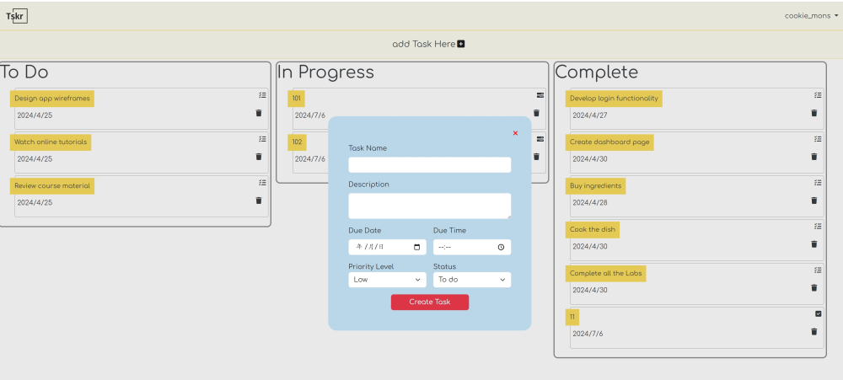
- task detail page
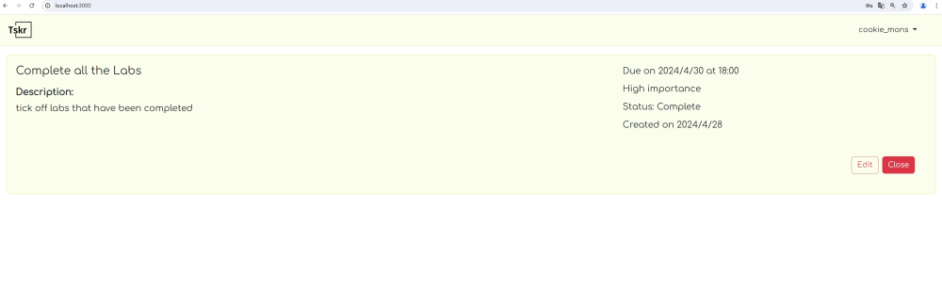
- edit task detail page
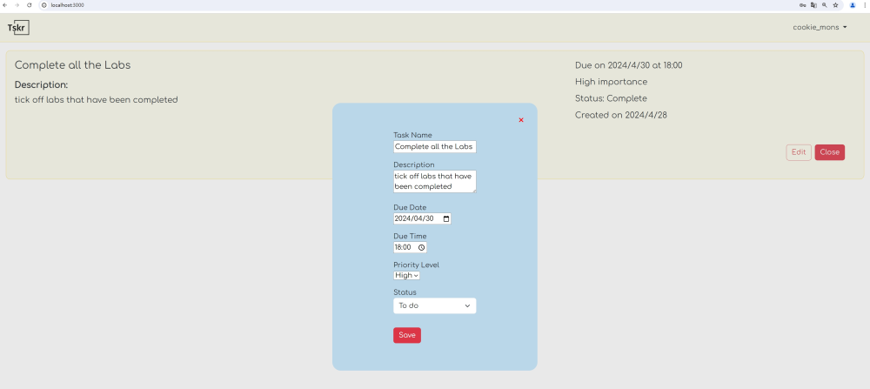
- change password page
